

PROJECT REPORT
DIGITAL LITERACY (CSE0001)

NAME: AARAV SHARMA
BRANCH : CSE (AIML)
REG NO. 25BAI10617
YEAR : 1st
DATE: 31/03/26

INTRODUCTION

In this project, I take on the role of a Student Digital Ambassador, where my responsibility is to guide and support my peers in understanding how to use digital tools effectively and safely. The main objective of this project is to create a Digital Literacy Portfolio that highlights important digital skills required in today’s academic and professional life.

To complete this project, I work on five different tasks, each focusing on a specific area of digital literacy. These include creating an awareness infographic, building a professional online presence using platforms like GitHub and LinkedIn, exploring coding and collaboration tools, learning proper email etiquette, and understanding cybercrime along with ways to prevent it.

Through this project, I gain practical knowledge and improve my confidence in using digital platforms responsibly. It also helps me understand the importance of maintaining a professional online identity and staying safe in the digital world.

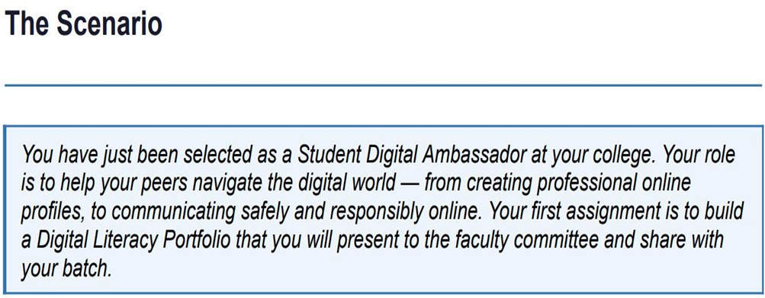

TASK-1

I created my one-page visual resource using Canva because it is easy to use and helps in making clean designs quickly. My infographic explains what digital literacy is and why it is important for students today. It includes topics like useful digital tools, safe internet practices, maintaining a professional online presence, and proper email etiquette. I used simple words, icons, and different colors so that the information is easy to understand and visually appealing. My aim was to help my batchmates understand how to use technology in a smart, safe, and responsible way.

While working on this, I really enjoyed trying different layouts, icons, and color combinations to make the design look interesting. At the same time, I found it a bit challenging to fit all the important points into one page without making it look too crowded. Overall, this task helped me improve my design skills and taught me how to present information in a clear and creative way.

TASK - 2

I chose GitHub, LinkedIn, and Kaggle as part of my digital portfolio because they are widely used platforms in the tech and professional world.
GitHub is mainly used to store and share projects, and I plan to use it to upload my coding work, assignments, and personal projects so that others can see my progress and skills.
LinkedIn is a professional networking platform where I can connect with other students, teachers, and industry professionals. I will use it to build my professional profile, share my achievements, and explore internship opportunities.
Kaggle is a platform focused on data science and machine learning, where users can work on datasets and participate in competitions. I plan to use Kaggle to practice data analysis, improve my problem-solving skills, and learn from real-world datasets.
Over the next four years, I aim to actively use these platforms to build a strong digital presence. By regularly updating my profiles and sharing my work, I hope to improve my skills, gain practical experience, and prepare myself for future career opportunities.

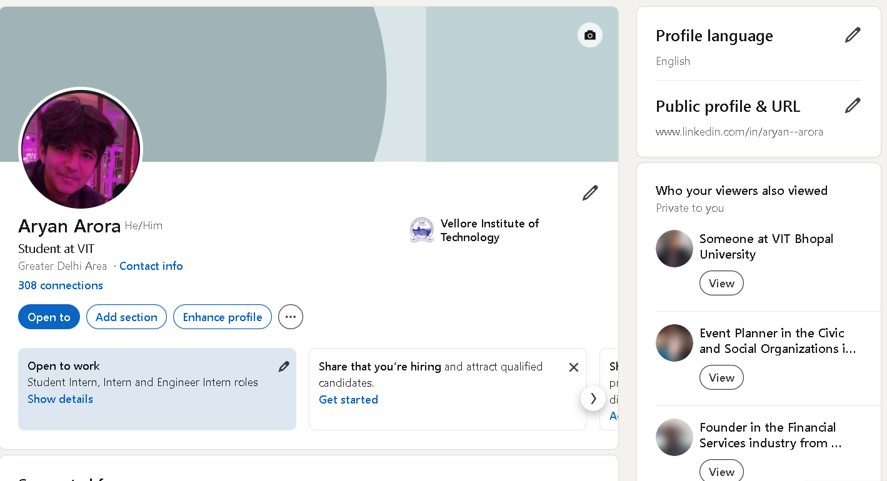

TASK-3

For this task, I used HackerRank as my coding practice platform and Google Forms for collaboration. On HackerRank, I solved a beginner-level Python problem that involved printing Hello World. This helped me revise basic programming concepts such as variables, input/output, and simple calculations. Practicing on HackerRank gave me hands-on experience and improved my confidence in writing and understanding code.
For the collaboration part, I created a Google Form as a Digital Literacy Awareness Quiz for my batchmates. This helped me understand how to design questions, collect responses, and organize data using Google Sheets. It also showed me how digital tools can be used effectively for communication and knowledge sharing.
These platforms will help me academically in many ways. Coding platforms like HackerRank will strengthen my problem-solving skills and logical thinking, which are important for exams and technical interviews. Tools like Google Forms will help me in projects, surveys, and teamwork. Overall, these tools will support my learning and help me become more confident in using technology for academic purposes.
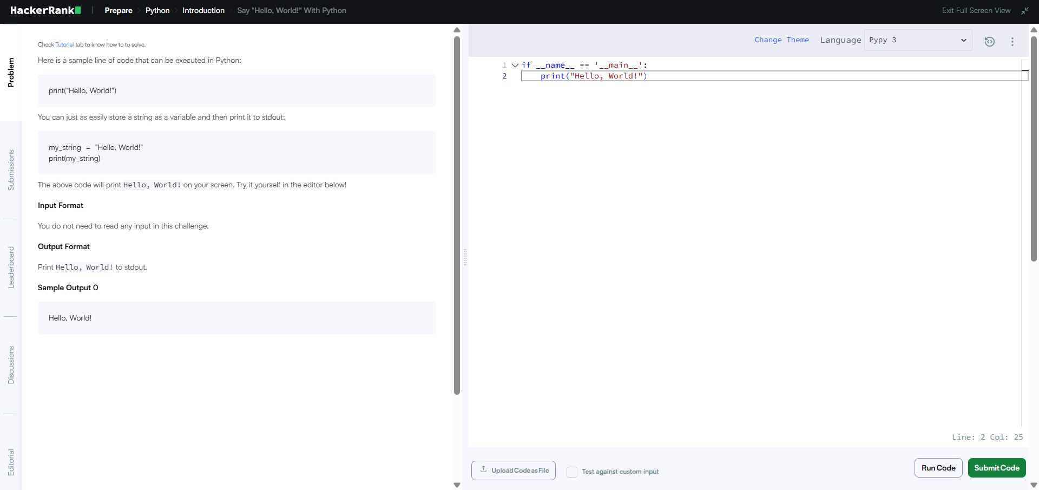

TASK-4

A common example of poor digital communication causing problems is when a student sends an unclear email to a professor about a deadline. For instance, a student might write a vague message like, “I can’t submit on time, please consider,” without mentioning the assignment name, reason, or requested extension date. The professor, receiving many emails, may ignore or misunderstand the request, resulting in a late submission penalty.
This situation could have been handled better with a clear subject line, proper greeting, and complete information. The student should have explained the reason briefly, specified the assignment, and politely requested a new deadline. Using a professional tone and structured format ensures the message is understood and increases the chances of a positive response.

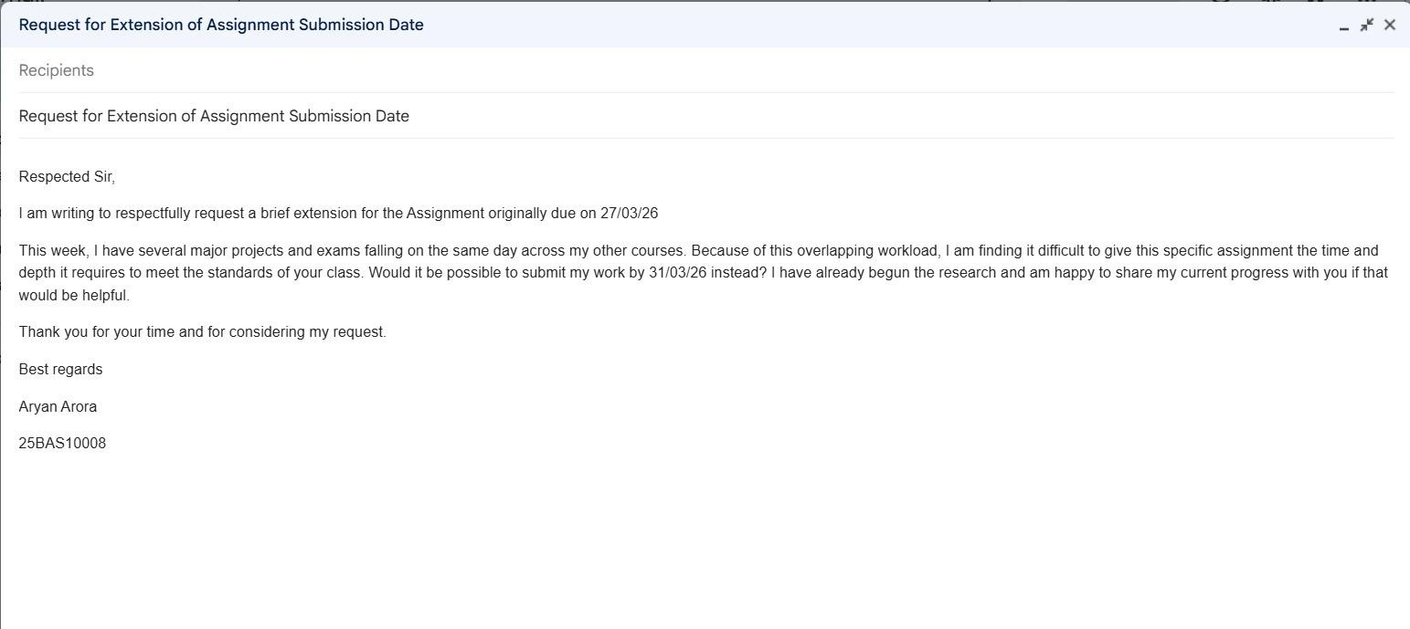

TASK-5

What I Did: I researched the psychological stages of cyberbullying and created a detailed case study and workflow diagram mapping how minor online incidents escalate into public harassment.
What Surprised Me: I was most surprised by how cyberbullying is driven by crowd psychology. The concept of the "spiral of silence" where bystanders stay quiet while opinion leaders drive the harassment showed me how easily toxic behavior becomes normalized online.
Habit I Will Change: Going forward, I will stop blindly reacting to or sharing viral online incidents without verifying the facts. I will also strictly audit my privacy settings to protect my digital footprint from being targeted by anonymous users.

